FOOTBALL STRATEGY DASHBOARD

The dashboard titled "Football Strategy Dashboard" provides a comprehensive view of various metrics related to football decision-making and trusted judgments during games. The primary focus is on analyzing the confidence levels of antecedent judgments, frequency of decisions, and the overall trustworthiness of judgments, along with other key statistics.

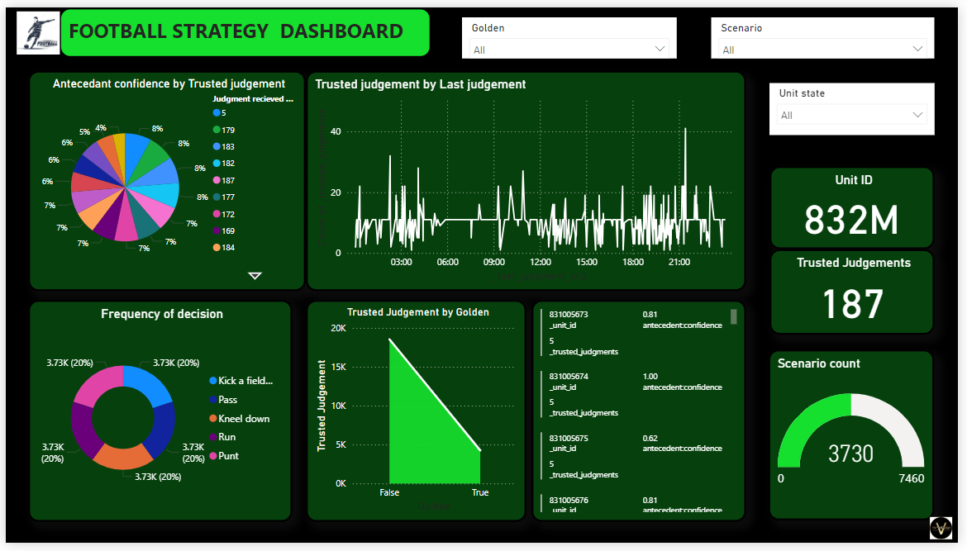

**ANALYSIS:**

1. **Antecedent Confidence by Trusted Judgment (Top Left Pie Chart):**
   * This pie chart breaks down the percentage distribution of antecedent confidence across different judgment IDs. The chart shows that the judgments are fairly evenly distributed, with the percentages ranging between 4% and 8% for each ID.
   * The IDs such as 183, 182, 179, 177, 172, etc., are the categories represented, indicating a varied set of data points with no single category overwhelmingly dominating.
2. **Trusted Judgment by Last Judgment (Top Middle Line Chart):**
   * This line graph tracks the number of trusted judgments made throughout the day, from early morning (03:00) to late evening (21:00).
   * The graph demonstrates fluctuations with certain peaks, indicating periods of higher judgment activity. The peaks in the graph suggest times when crucial decisions were likely made, and the trust level in these judgments was high.
3. **Frequency of Decision (Bottom Left Pie Chart):**
   * This donut chart displays the frequency of different decisions such as "Kick a field goal," "Pass," "Kneel down," "Run," and "Punt," each accounting for 20% of the total decisions.
   * The equal distribution suggests a balanced strategy where no single decision type dominates the play calls, indicating a well-rounded approach to gameplay.
4. **Trusted Judgment by Golden (Bottom Middle Bar Chart):**
   * This bar chart compares the count of trusted judgments classified as "True" versus "False" under a metric labeled "Golden."
   * The chart shows a stark contrast, with a significantly higher number of judgments being classified as "False" compared to "True," implying a potential issue in decision-making or the criteria for trustworthiness.
5. **Unit ID and Trusted Judgments (Right Side Panels):**
   * The dashboard highlights specific metrics like the "Unit ID" (832M) and the total count of "Trusted Judgments" (187), providing a snapshot of the current focus area.
   * Additionally, a gauge visual indicates the "Scenario Count," with a current value of 3730 out of a maximum of 7460, giving a quick view of progress or completion rate of certain scenarios.

**INSIGHTS:**

* **Balanced Strategy:** The evenly distributed frequency of decisions implies a strategy that does not overly rely on any single type of play, which could indicate adaptability and unpredictability in game plans.
* **Judgment Activity Patterns:** The line chart suggests that there are key periods during the day when critical decisions are made, which could align with certain phases of a match or training session.
* **Potential Trust Issues:** The significant difference in trusted judgments categorized as "False" versus "True" under the "Golden" metric could highlight areas needing review, possibly indicating inconsistency or issues in decision validation.

**KEY POINTS:**

• Review Decision-Making Processes: The high rate of "False" trusted judgments under the "Golden" category suggests the need for a thorough review of the criteria or the process used for validating judgments.

• Analyze Peak Times: Investigate the reasons behind the peaks in trusted judgments during certain hours to understand better what factors are contributing to these trends, such as specific game conditions or external influences.

• Balanced Play Calls: Continue to monitor the distribution of decision types to maintain a balanced and unpredictable game strategy, which could be advantageous in competitive scenarios.

**CONCLUSION:**

The Football Strategy Dashboard provides valuable insights into the team's decision-making processes, judgment validation, and overall strategy execution. By addressing potential issues in trusted judgments and maintaining a balanced approach to play calling, the team can optimize its performance on the field.